ST-5 SUMMARY

ST-5 Test Stats | #
Test cases planned for this sprint | 24
Test cases COMPLETED (without errors) | 20 | WHICH FR? | FR 2.2, 2.3 NEW  FR 3, 3.1, 3.2, 3.3, 3.4 NEW  FR 4, 4.1, 4.3  FR 5 NEW  FR 9.3 NEW  FR 11 NEW  FR 3.1 (RETEST)  FR 6 (RETEST)  FR 8.1, 8.2 (RETEST)  FR 9.1 (RETEST)  FR 12.1 (RETEST)
Test cases NOT COMPLETED | 4 | WHY? | FR 1.3 UNSUCCESSFUL (RETEST)- bug under development  FR 9.2 PARTIALLY SUCCESSFUL (NEW)- shows late but not “on-time” status  FR 9.4 PARTIALLY SUCCESSFUL (NEW)- shows late status but # of days late is wrong  FR 12 PARTIALLY SUCCESSFUL (RETEST)- no functional filter, only search bar
DEFECTS found | 2 | STATUS: | ST5_Defect 1: QA Related (not reported to Full-stack)  ST5_Defect 2: Open

FR 2.2, 2.3 - NEW
STP Test Case # ST-5
Requirement tested: FR-2.2
Description: The system shall retrieve selected week’s weekly report submissions for all the students for the instructor's summary.
Build: v0.3.0_20260405
Determination: SUCCESSFUL

Setup:
- Open Chrome browser on MAC
- Navigate to front-facing AWS server (https://lakertracks.duckdns.org/)
- Execute test

Execution:
- Log in as an instructor.
- Navigate to the instructor home page.
- Allow the system to request associated course data.
- Wait for the course list to load.
- Verify all courses assigned to the instructor are displayed.

Expected Result:
Login as an instructor. View the courses retrieved for the instructor

Actual Results:
Instructor is successfully logged in and redirected to the home page. The system retrieves associated course data without errors and all courses assigned to the instructor are displayed accurately.

Screenshot:
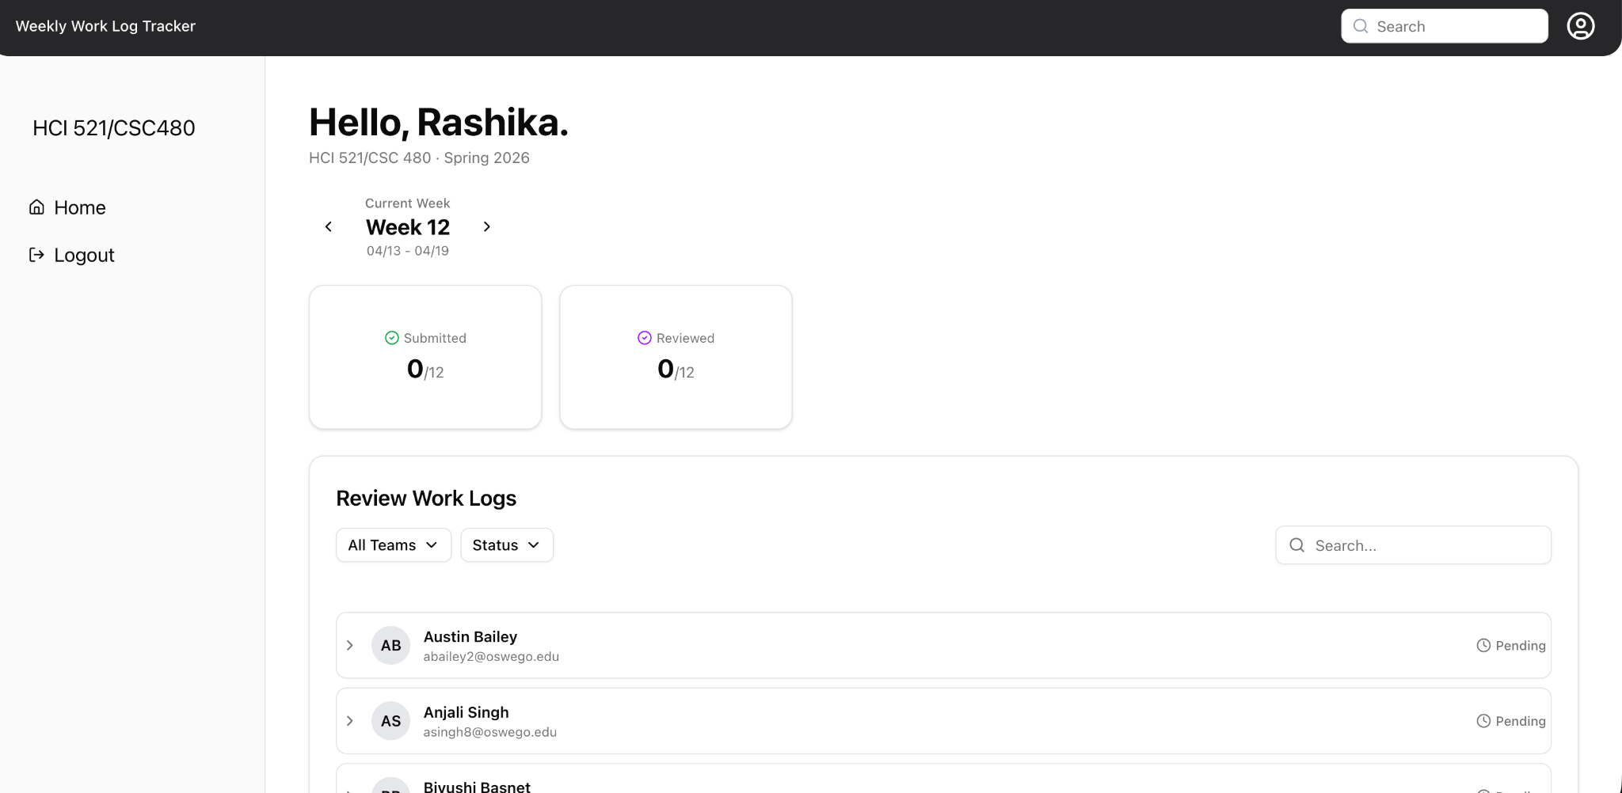

STP Test Case # ST-5
Requirement tested: FR-2.3
Description: The system shall retrieve weekly report submission status for students in each course.
Build: v0.3.0_20260405
Determination: SUCCESSFUL

Setup:
1. Open Chrome browser on MAC
2. Navigate to front-facing AWS server (https://lakertracks.duckdns.org/)
3. Execute test

Execution:
1. Log in as an instructor.
2. Navigate to a specific course page.
3. Request weekly report submission status.
4. Wait for student data retrieval.
5. Verify each student’s submission status is displayed correctly.
Expected Result:
Opens the page and gives the submission report status summary for students.

Actual Results:
Each student’s weekly report submission status (e.g., Submitted, Missing) is shown accurately.

Screenshot:
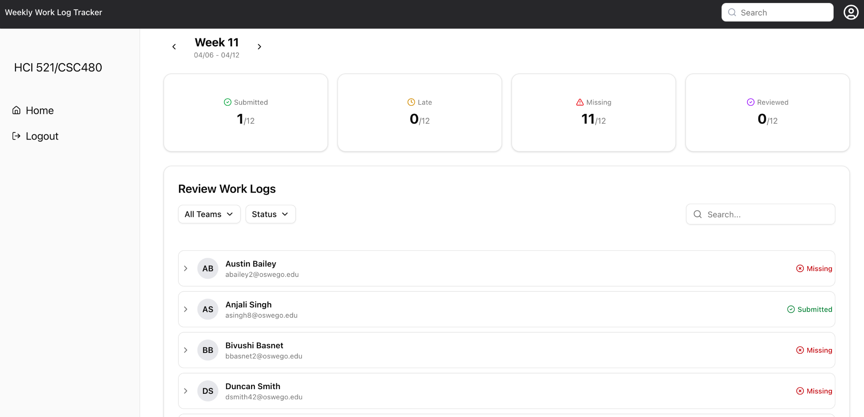

FR 3, 3.1, 3.2, 3.3, 3.4 - NEW
STP Test Case # ST-5

Requirement tested: FR- 3
Description: The system shall display the current weekly report status on the student home page.
Build: v0.3.0_20260405
Determination: SUCCESSFUL

Setup:
1. Open Chrome browser on MAC
2. Navigate to front-facing AWS server (https://lakertracks.duckdns.org/)
3. Execute test

Execution:
1. Log in as a student
2. Navigate to the Student Home Page
3. Observe if a weekly report status is displayed on the student home page

Expected Result:
Should be able to open the page and view weekly report status.
Actual Results:
The status (e.g., Submitted, Not Submitted, Pending) is accurate and corresponds to the current week.
Screenshot:
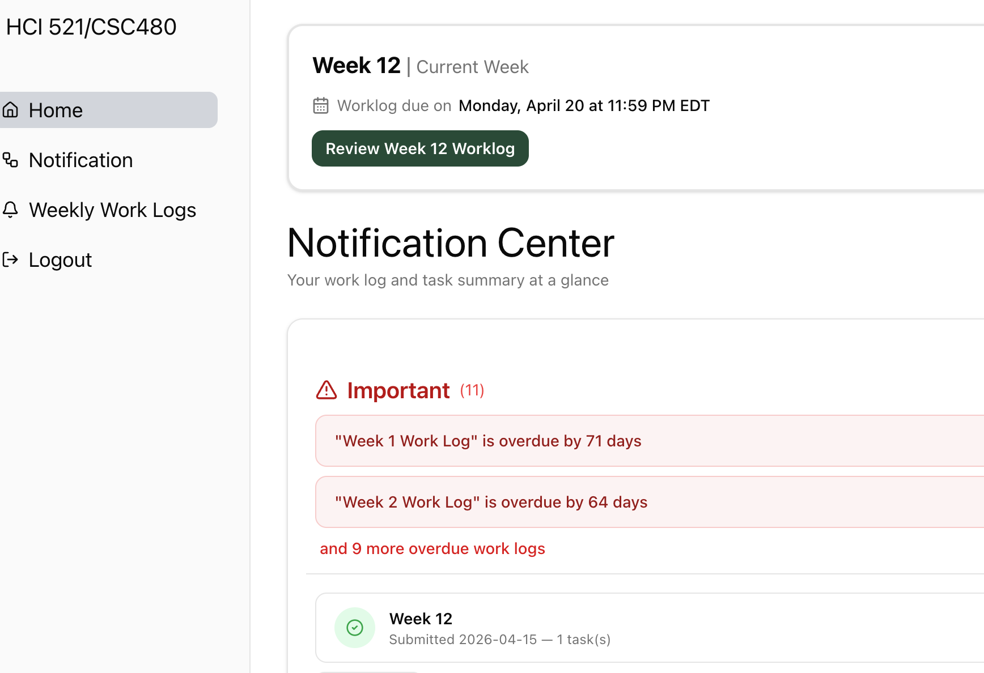
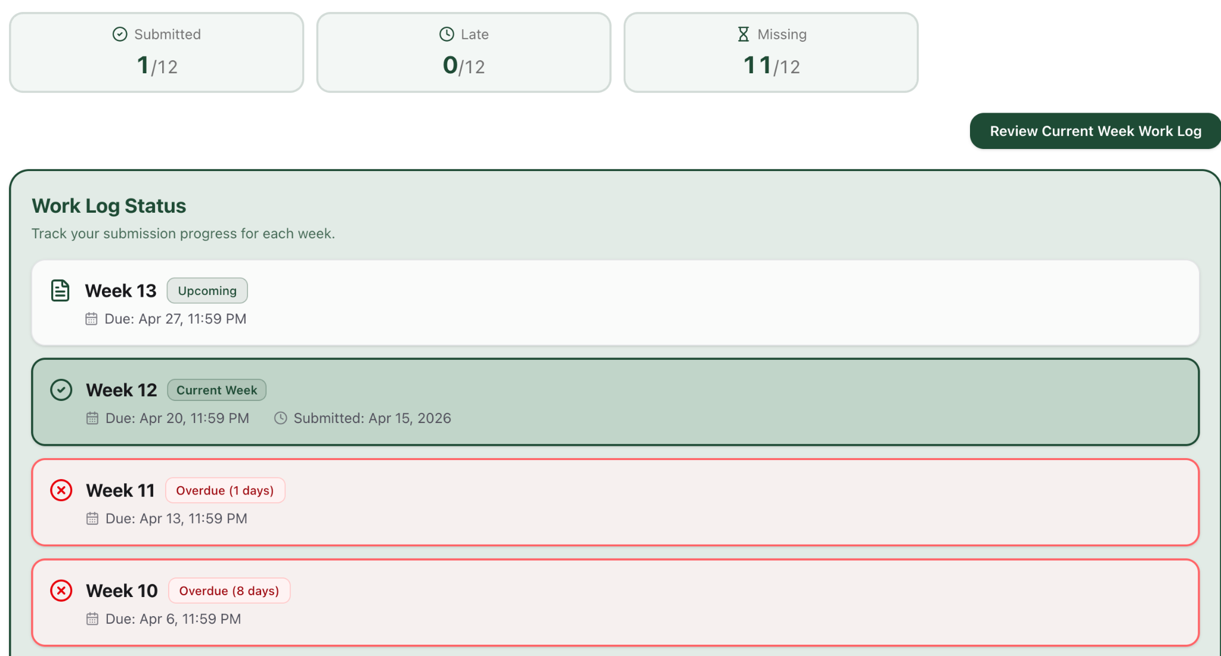

Requirement tested: FR 3.1
Description: The system shall retrieve the current reporting period for the student.
Build: v0.3.0_20260405
Determination: SUCCESSFUL

Setup:
- Open Chrome browser on Mac OS
- Navigate to front-facing Moxie server (https://lakertracks.duckdns.org/)
- Execute test

Execution:
- Log in as a student.
- Navigate to the Student Home Page.
- Observe the displayed reporting period.
- Compare displayed reporting period with expected current period (from test data or database).

Expected Result:
Week number and date should show in both the Homepage and Notification page for the student dashboard.
What to expect : Week number and date

Screenshot:
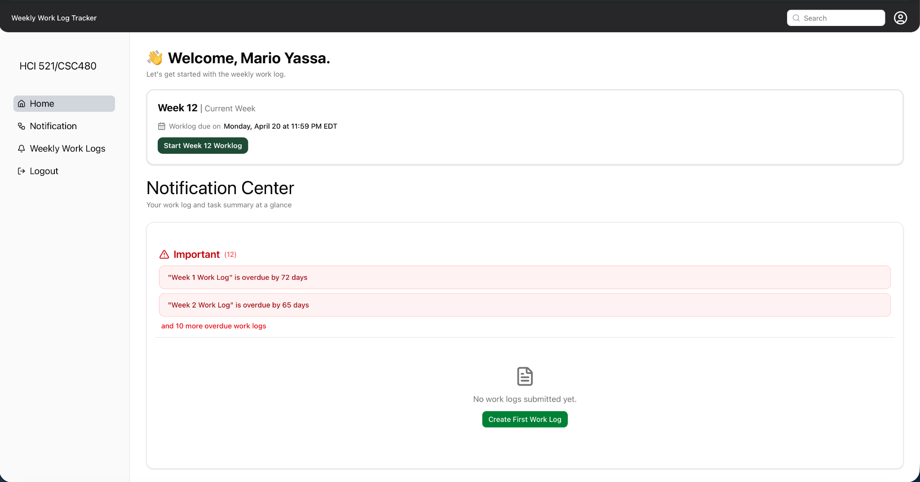

Requirement tested: FR 3.2
Description: The system shall retrieve the student’s weekly report for the current reporting period.
Build: v0.3.0_20260405
Determination: SUCCESSFUL

Setup:
- Open Chrome browser on Mac OS
- Navigate to front-facing Moxie server (https://lakertracks.duckdns.org/
- Execute test

Execution:
- Log in as a student with an existing weekly report for the current period.
- Navigate to the Student Home Page.
- Locate the weekly report section.
- Observe report data displayed.

Expected Result:
The student sees the weekly report for that week
What to expect : Weekly report on the notification Page

Screenshot:
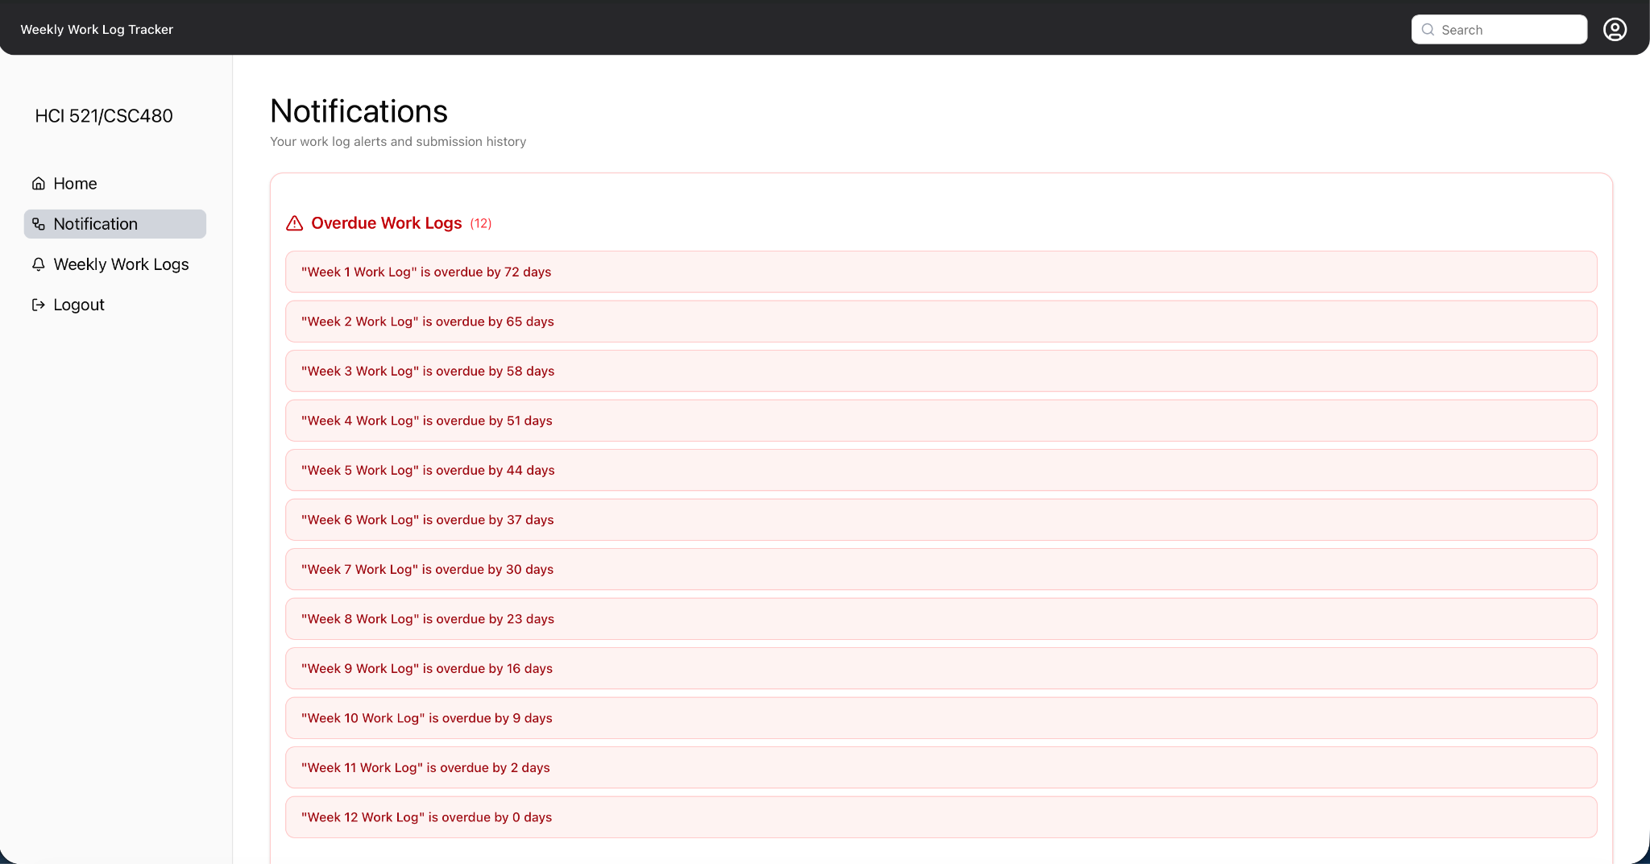

Requirement tested: FR 3.3
Description: The system shall determine the report status based on the presence of required fields.
Build: v0.3.0_20260405
Determination: SUCCESSFUL

Setup:
- Open Chrome browser on Mac OS
- Navigate to front-facing Moxie server (https://lakertracks.duckdns.org/)
- Execute test

Execution:
- Log in as a student.
- Create a weekly report.
- Fill in all required fields.
- Save or submit the report.
- Return to the Student Home Page.
- Observe the report status.

Expected Result:
The system updates the report status of student submits or saves
What to expect : status change

Screenshot:

Requirement tested: FR 3.4
Description: The system shall retrieve the current reporting period for the student.
Build: v0.3.0_20260405
Determination: SUCCESSFUL

Setup:
- Open Chrome browser on Mac OS
- Navigate to front-facing Moxie server (https://lakertracks.duckdns.org/)
- Execute test

Execution:
- Log in as a student with NO weekly report for the current period.
- Navigate to the Student Home Page.
- Observe the report status section.

Expected Result:
The system should display a "overdue" message if student didn't submit a weekly report
What to expect : A red cross button next to not submitted worklogs

Screenshot:
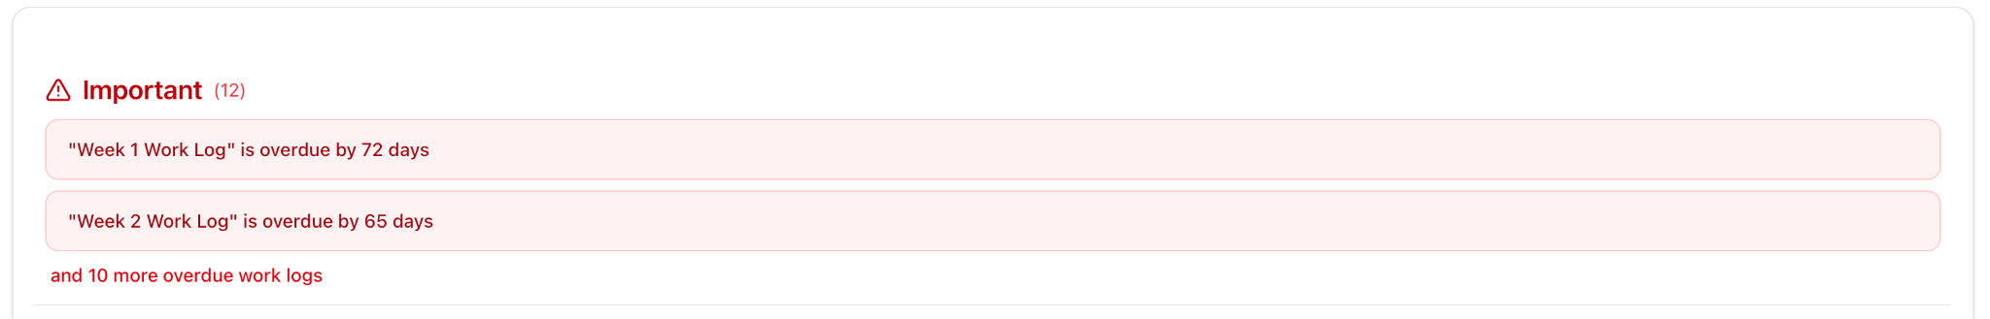

FR 4, 4.1, 4.3 - NEW

STP Test Case # ST-5

Requirement tested: FR 4
Description: The system shall validate weekly report inputs before determining completion status.
Build: v0.3.0_20260405
Determination: SUCCESSFUL

Setup:
- Open Chrome on Windows OS
- Navigate to front-facing Moxie server (https://lakertracks.duckdns.org/)
- Execute test

Execution:
- Log in with valid student id
- Click start worklog
- Fill in worklog info leaving.
- Click submit worklog

Expected Result:
The website should submit the worklog.

Screenshot:
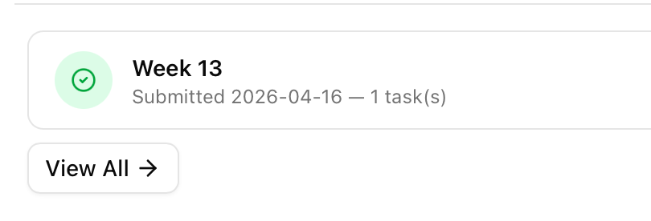

Requirement tested: FR 4.1
Description: The system shall verify that all required weekly report fields are present.
Build: v0.3.0_20260405
Determination: SUCCESSFUL

Setup:
- Open Chrome on Windows OS
- Navigate to front-facing Moxie server (https://lakertracks.duckdns.org/)
- Execute test

Execution:
- Log in as a student.
- Navigate to weekly report form.
- Leave at least one required field empty.
- Attempt to submit the report.
- Return to the Student Home Page.
- Observe report status.

Expected Result:
If incompleted worklog is attempted to be submitted the notification page remains as worklog missing.
What to expect : Red X next to specified worklog in notification center

Screenshot:
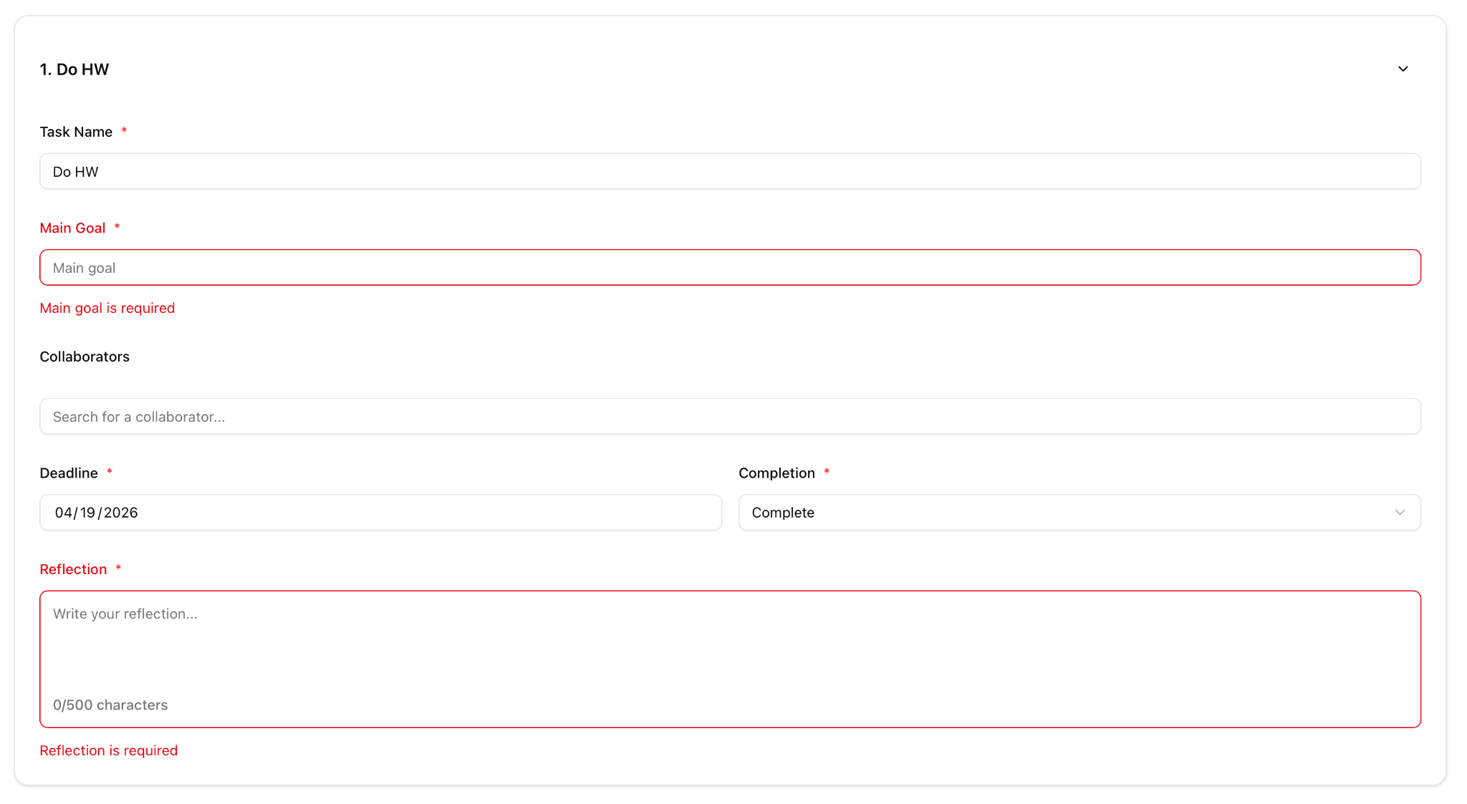

Requirement tested: FR 4.3
Description: The system shall prevent incomplete weekly reports from being marked as complete.
Build: v0.3.0_20260405
Determination: SUCCESSFUL

Setup:
- Open Chrome on Windows OS
- Navigate to front-facing Moxie server (https://lakertracks.duckdns.org/)
- Execute test

Execution:
- Log in as a student.
- Open weekly report form.
- Leave at least one required field empty.
- Observe the “Mark as Complete” button.

Expected Result:
If incompleted worklog is attempted to be submitted the notification page remains as a worklog missing.

Screenshot:
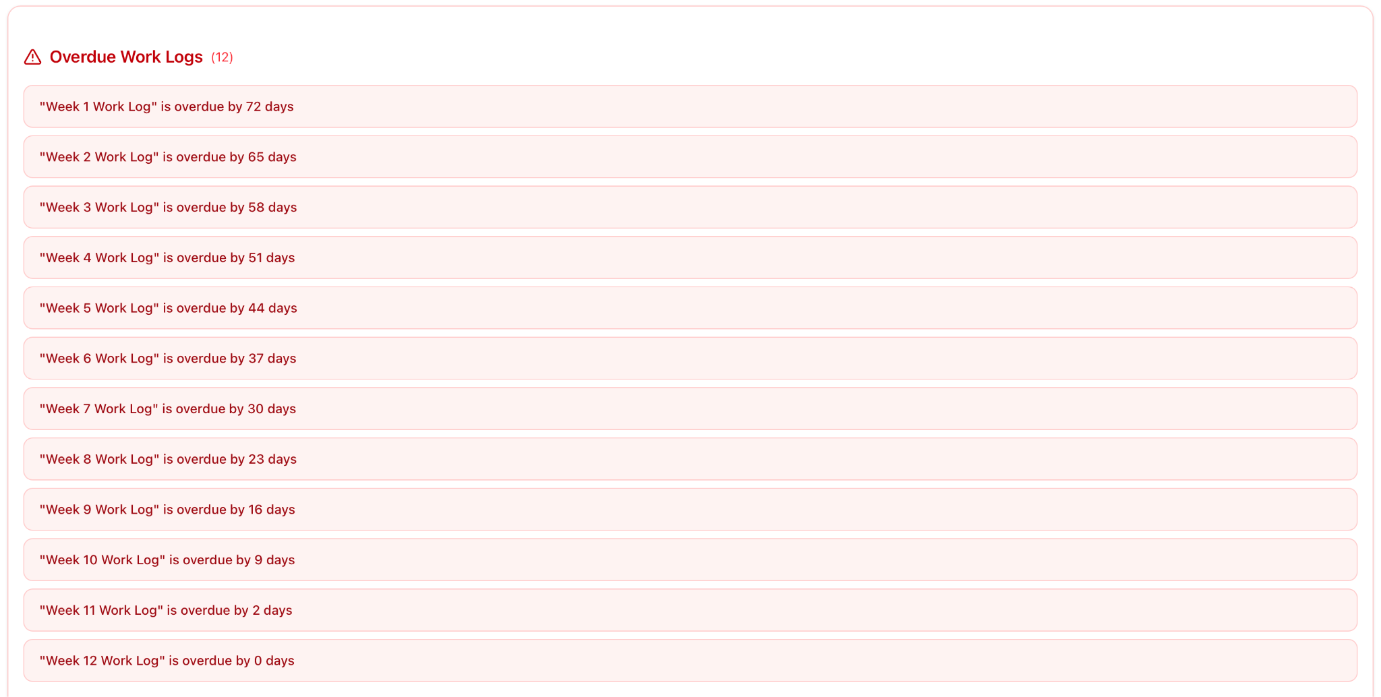
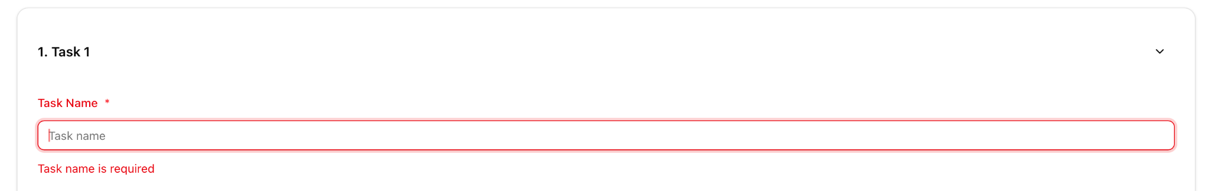

FR 5 - NEW
STP Test Case # ST-5
Requirement tested: FR-5
Description: The system shall validate weekly report inputs during submission.
Build: v0.3.0_20260405
Determination: SUCCESSFUL

Setup:
1. Open Chrome browser on MacOS
2. Navigate to front-facing AWS server (https://lakertracks.duckdns.org/)
3. Execute test

Execution:
- Log in as a student
- Fill out a new worklog and try submitting with fields missing
- Fill worklog out completely and submit

Expected Result:
The system shall only allow submission if all fields (excluding the collaborators) are filled out
Actual Results:
The system was able to flag when a field was not filled out, and the worklog was successfully submitted if all fields were filled out

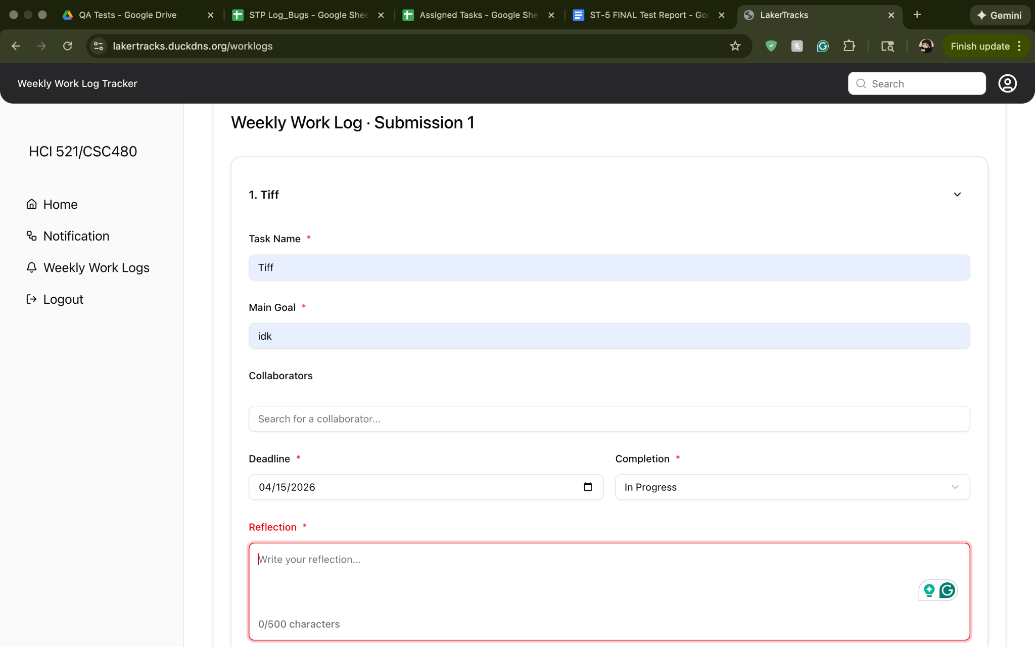
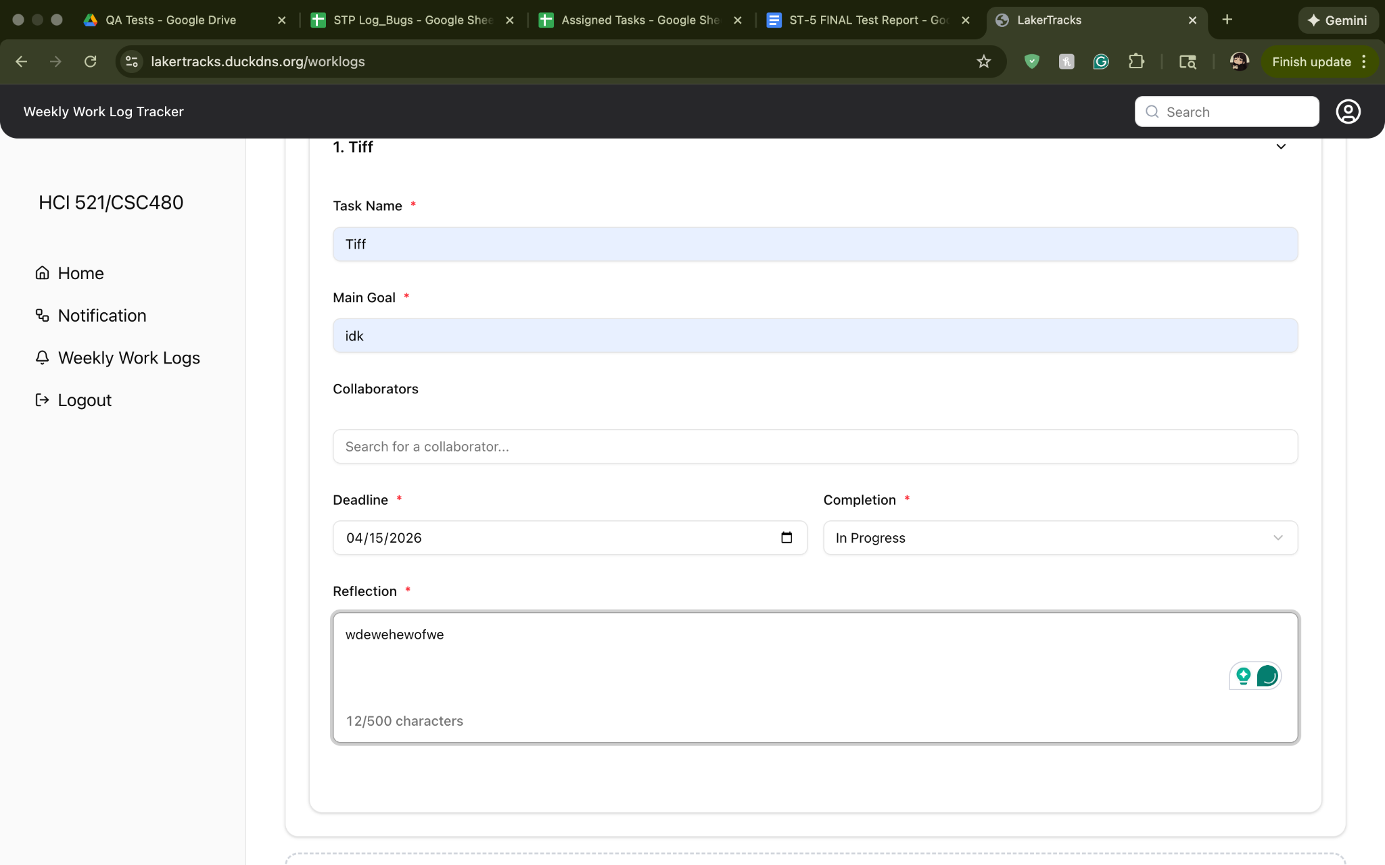
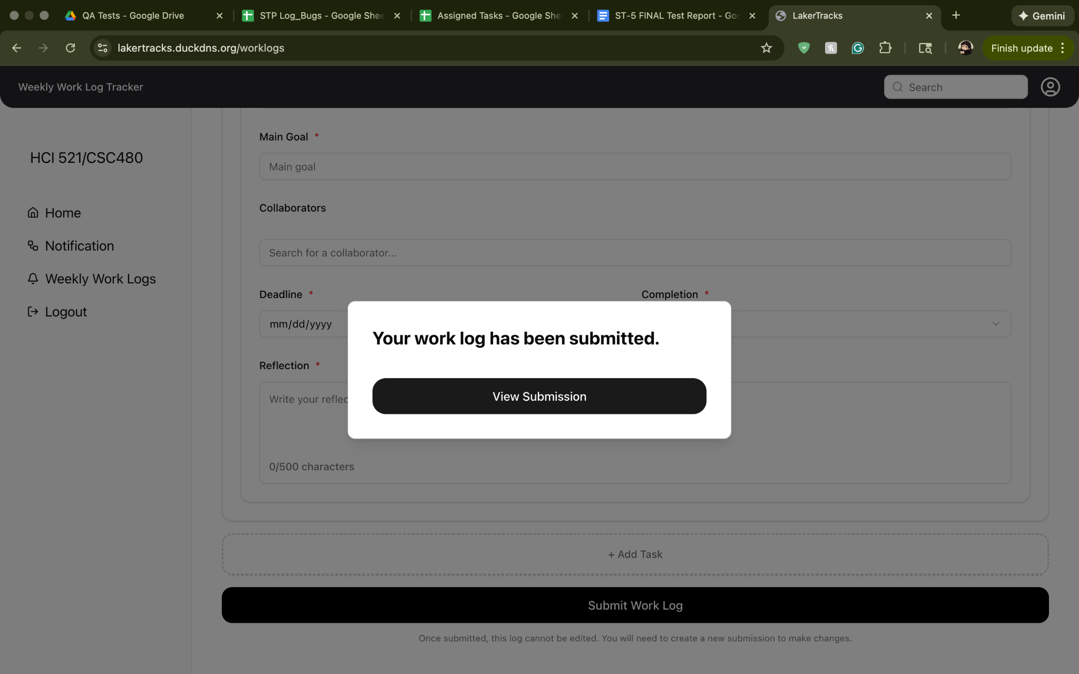

FR 9.2, 9.3, 9.4 - NEW

STP Test Case # ST-5
Requirement tested: FR-9.2
Description: The system shall compare the submission timestamp with the worklog deadline.
Build: v0.3.0_20260405
Determination: PARTIALLY SUCCESSFUL

Setup:
- Open Chrome browser on Windows OS
- Navigate to front-facing AWS server (https://lakertracks.duckdns.org/)
- Execute test

Execution:
- Log in as a student.
- Navigate to the Worklogs page.
- Locate the worklog deadline for the current reporting period.
- Fill in required worklog fields.
- Click Submit Worklog.
- Observe the submission status (on-time/late).

Expected Result:
User should be able to submit a worklog and see that the system compares the submission timestamp with the worklog deadline and displays the correct submission status (on-time or late).

Actual Results:
The system should display whether it's late or whether it's on-time but it only shows if it's late. It does show when the deadline is and when it was submitted but nothing that explicitly says “on-time”.

Screenshot:
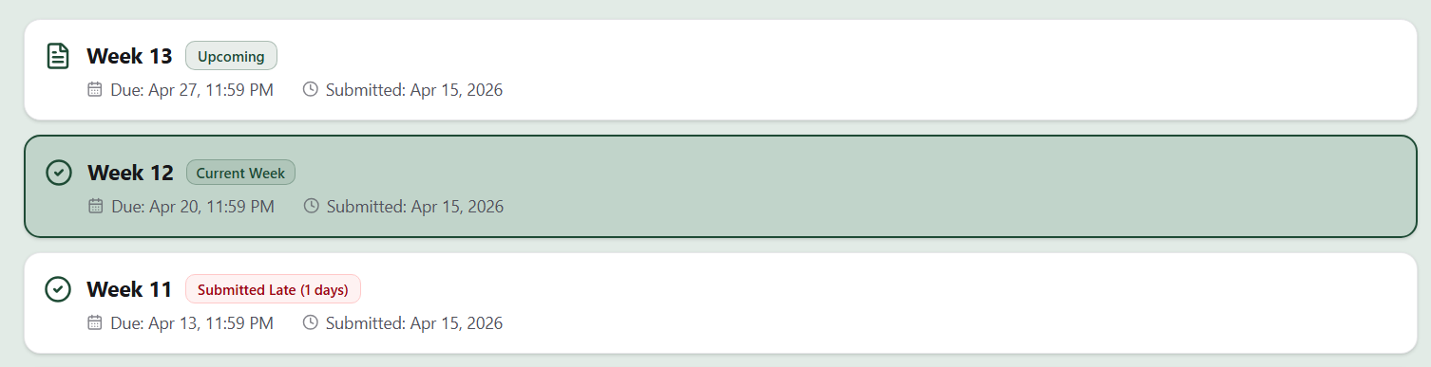

STP Test Case # ST-5
Requirement tested: FR-9.3
Description: If the submission occurs after the deadline, the system shall mark the worklog as late.
Build: v0.3.0_20260405
Determination: SUCCESSFULl

Setup:
- Open Chrome browser on Windows OS
- Navigate to front-facing AWS server (https://lakertracks.duckdns.org/)
- Execute test

Execution:
- Log in as a student.
- Navigate to the Worklogs page.
- Locate the worklog deadline for the current reporting period.
- Submit the worklog after the deadline has passed (use test data where the deadline is already passed).
- Fill in required worklog fields.
- Click Submit Worklog.
- Observe the submission status.

Expected Result:
User should be able to submit a worklog after the deadline and see that the system marks the submission status as late.

Actual Results:
The system marks it as late as it should.

Screenshot:
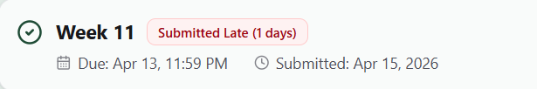

STP Test Case # ST-5
Requirement tested: FR-9.4
Description: The system shall calculate and record the number of days a worklog submission is late.
Build: v0.3.0_20260405
Determination: PARTIALLY SUCCESSFUL

Setup:
- Open Chrome browser on Windows OS
- Navigate to front-facing AWS server (https://lakertracks.duckdns.org/)
- Execute test

Execution:
1) Log in as a student.
2) Navigate to the Worklogs page.
3) Locate the worklog deadline for the current reporting period.
4) Submit the worklog after the deadline by a known number of days (use test data where the deadline is already passed).
5) Fill in required worklog fields.
6) Click Submit Worklog.
7) Open the submitted worklog details (or submission confirmation page).
8) Observe the “days late” value (or late duration field) shown.

Expected Result:
User should be able to submit a worklog late and see that the system calculates and displays the correct number of days late on the submitted worklog details (or confirmation page).

Actual Results:
The system marks it as late but does not properly display the number of days late it was.
Screenshot:


FR 11 - NEW
STP Test Case # ST-5
Requirement tested: FR-11
Description: The system shall allow instructors to mark submitted worklogs as reviewed or graded.
Build: v0.3.0_20260405
Determination: SUCCESSFUL

Setup:
1. Open Chrome browser on MacOS
2. Navigate to front-facing AWS server (https://lakertracks.duckdns.org/)
3. Execute test

Execution:
1. Navigate to Instructor homepage
2. Select worklog to Review
3. Mark Worklog as Reviewed

Expected Result:
The instructor should be able to mark a worklog as Reviewed (as a status).
Actual Results: A worklog was able to be marked as reviewed successfully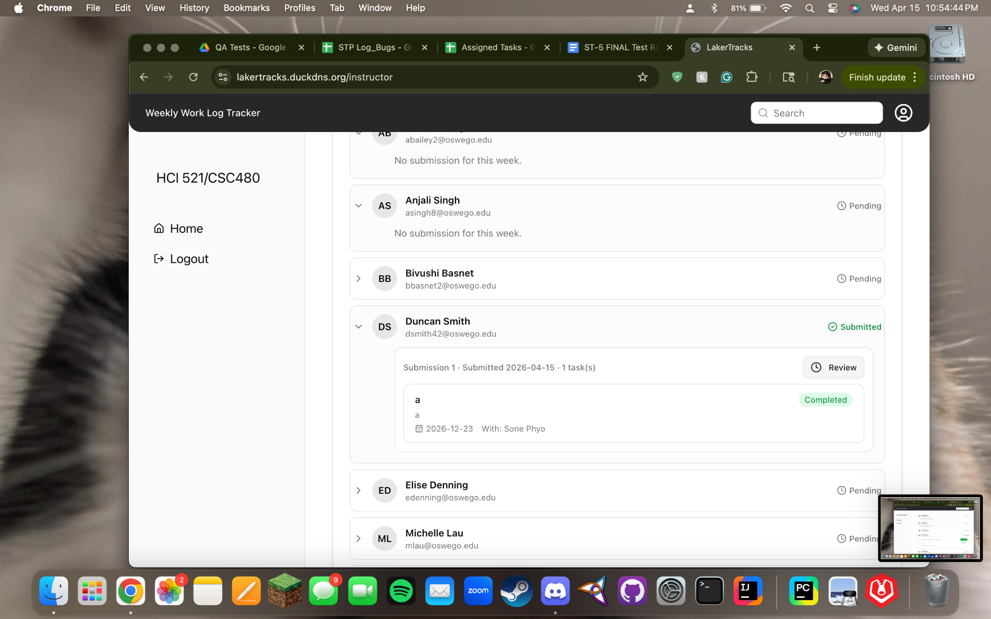
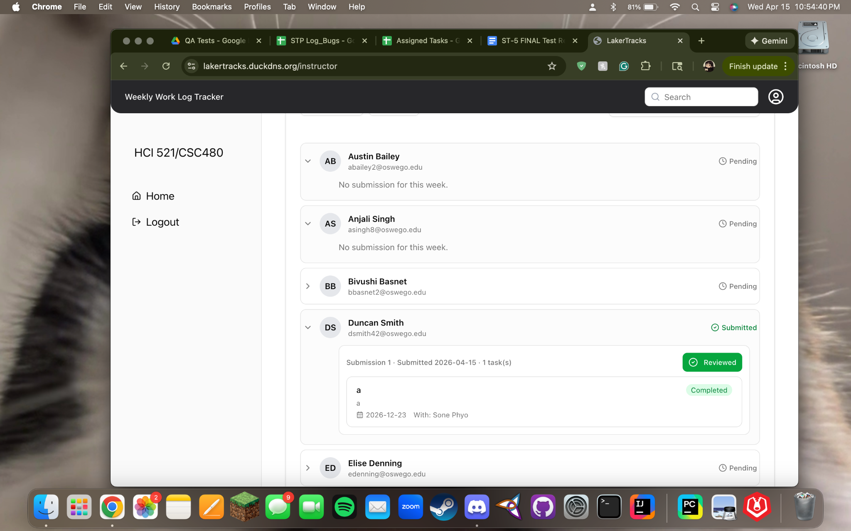

FR 12 - NEW
STP Test Case # ST-5
Requirement tested: FR-12
Description: The system shall allow instructors to filter student worklog submissions.
Build: v0.3.0_20260405
Determination: PARTIALLY SUCCESSFUL

Setup:
- Open Chrome browser on Windows OS
- Navigate to front-facing AWS server (https://lakertracks.duckdns.org/)
- Execute test

Execution:
- Log in as an instructor.
- Navigate to the instructor worklog submissions page.
- Locate the filter options (e.g: by student name, date, status).
- Select a filter (eg: “Not Submitted” or a specific student).
- Apply the filter.
- Observe the displayed list of worklog submissions.

Expected Result:
The system should allow me to select a filter and the students/ worklogs should be sorted according to the filter name

Actual Results:
The system does not have a functional filter button. The All Teams and Status button is the only option. This does not allow you to filter student’s worklogs. There is a functional search bar that allows you to search students and view their worklogs

Screenshot:
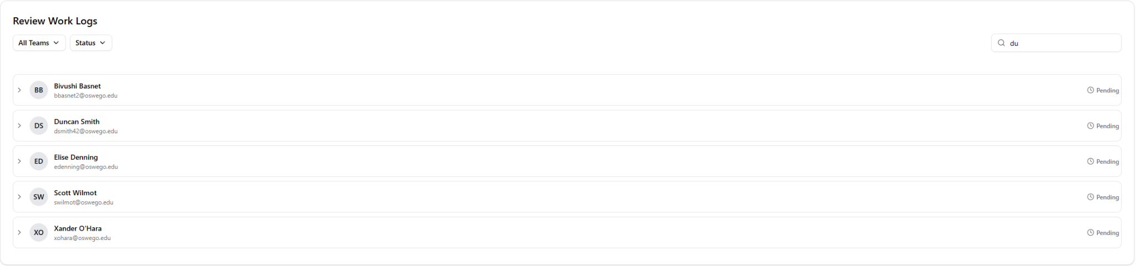

FR 1.3 - RETEST

Requirement tested: FR 1.3

Description: The system shall retrieve role-specific home page data based on the extracted role.
Build: v0.3.0_20260405
Determination: UNSUCCESSFUL - Bug under development

Setup:

Open Safari browser on Mac OS
Navigate to front-facing Moxie server (http://moxie.cs.oswego.edu:7000/)
Execute test

Execution:
- Log in as a user with a specific role .
- Allow the system to validate the authentication token.
- Access the home page.
- Observe the data retrieved for display.
- Verify the displayed data matches the logged in user’s role.

Expected Result:
- When logged in as student
  - Notification centre on the homepage should be populated with details of submitted worklog, if submitted

- When logged in as an instructor
  - Should see the submitted worklog detail by the student
What to expect : Distinct homepage with role specific data

Actual Result:

- When logged in w my school id / student :
  - Created a new worklog
  - Submitted the worklog
  - Notification center updated with the new worklog detail
  - Recent submission’s notification NOT on top of the notification centre

Bug Found :
The notification for the most recent work log submission was not on the top of the notification center; instead the old notification was on the top.

Screenshot -
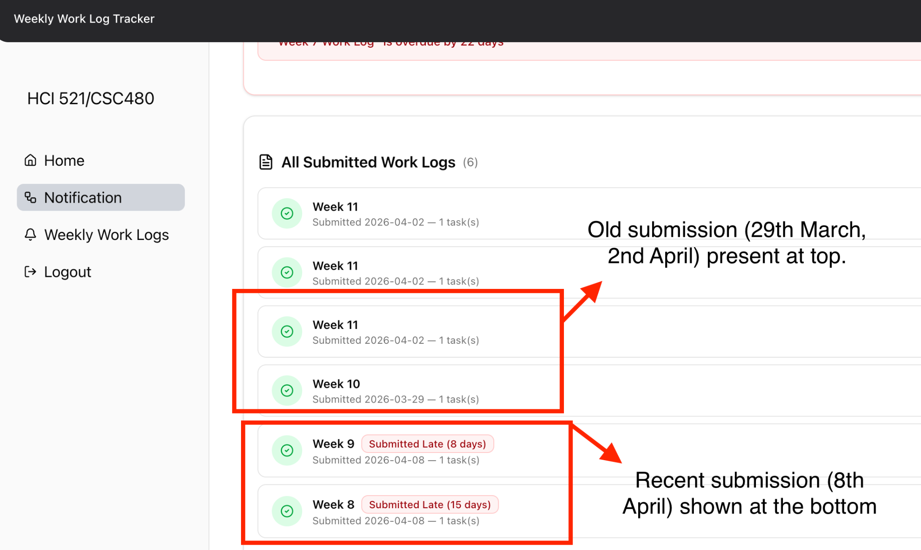

Bug Update (Github) : 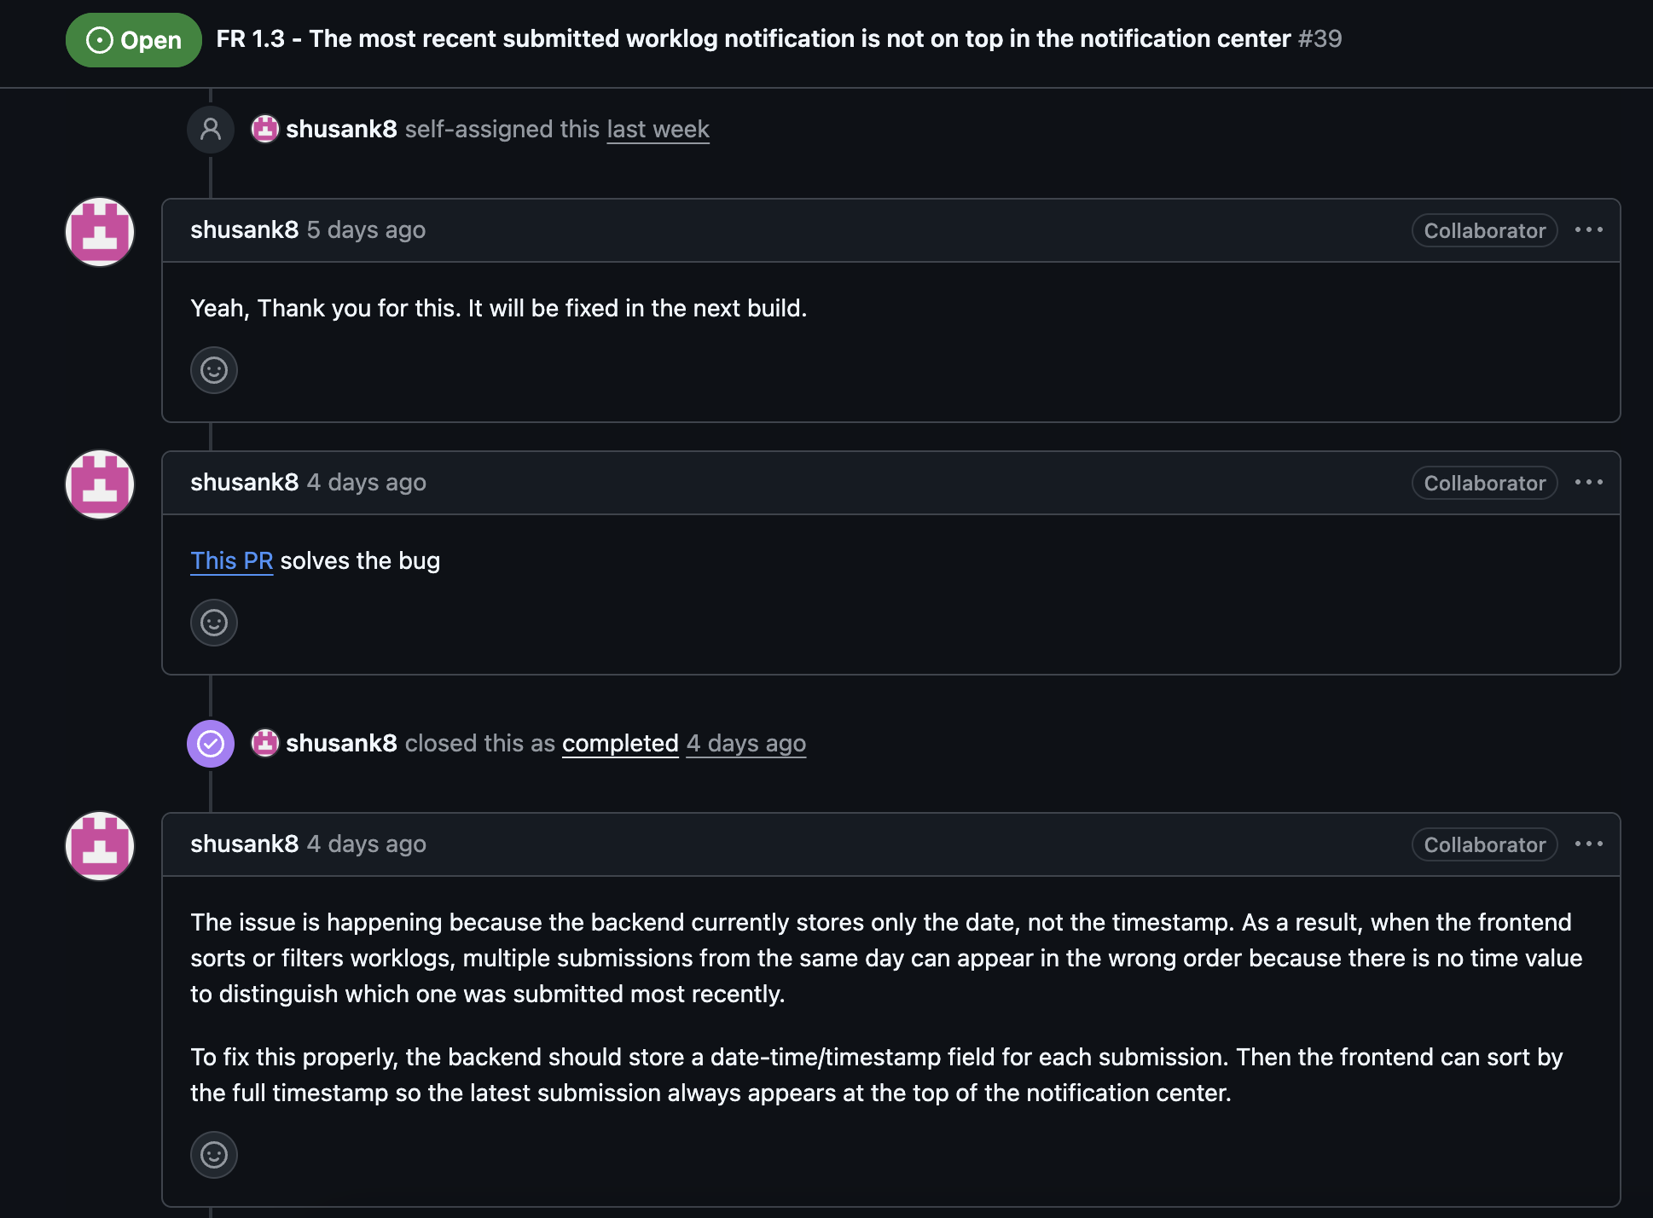

FR 2.5 - RETEST
Requirement tested: FR-2.5
Description: If weekly report data retrieval fails, the system shall display a partial summary with an error message.
Build: v0.3.0_20260405
Determination: SUCCESSFUL

Setup:
Open Google Chrome on MacOS
Navigate to front-facing Moxie server (http://moxie.cs.oswego.edu:7000/)
Execute test

Execution:
- Log in as an instructor.
- Simulate a failure in weekly report data retrieval.
- Navigate to the instructor dashboard.
- Allow the system to attempt data retrieval.
- Verify a partial summary is displayed along with an appropriate error message.

Expected Result:
- When logged in as instructor
  - Error message is displayed on components that fetches data from backend including Homepage, Notification Page

Screenshot:
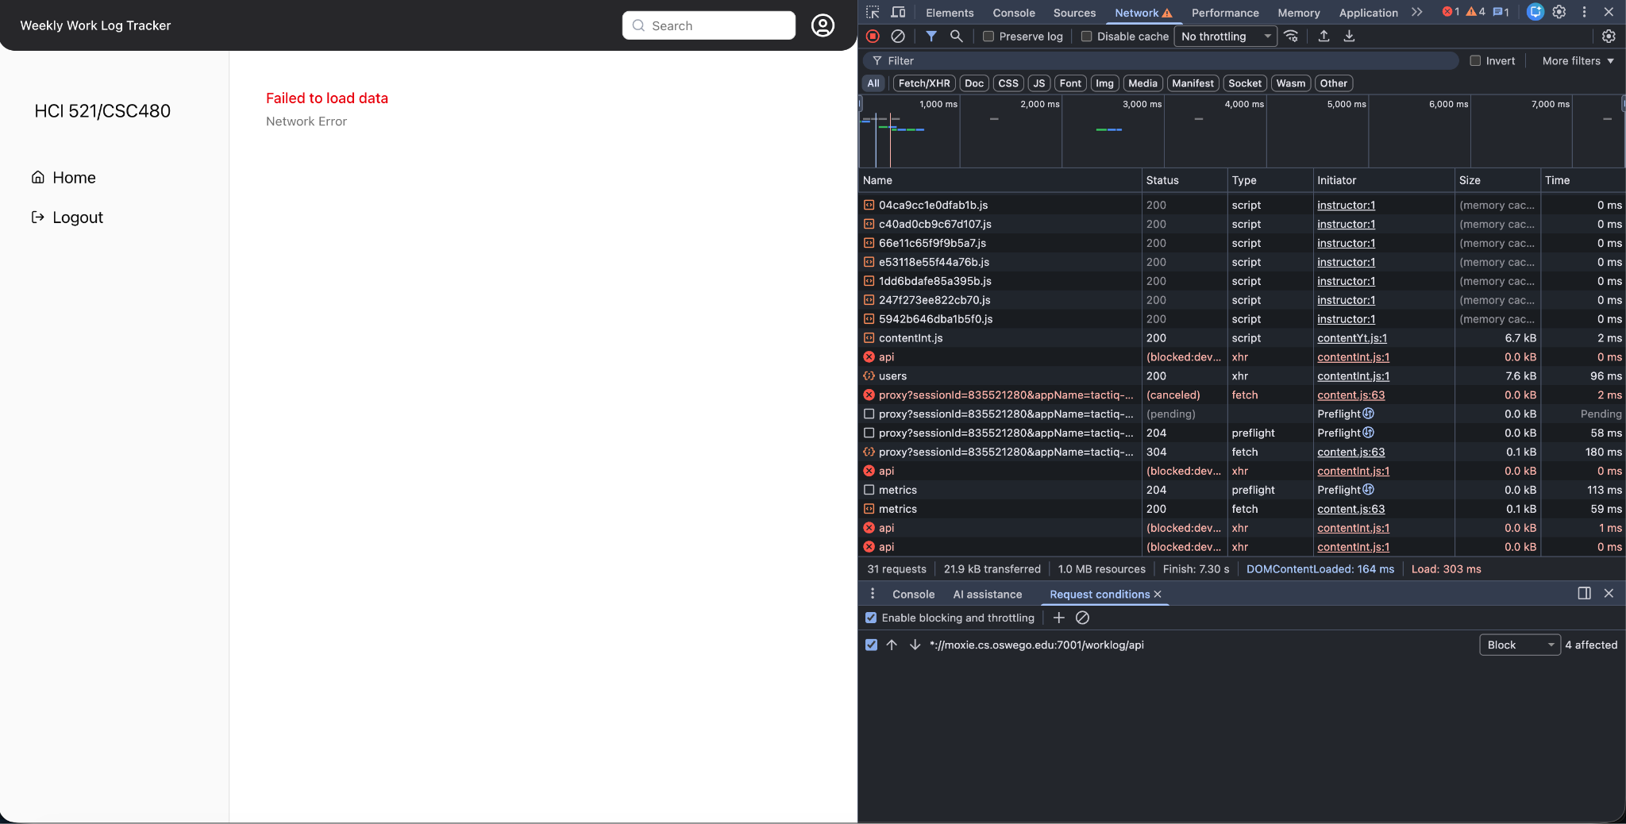

FR 3.1 - RETEST

Requirement tested: FR 3.1
Description: The system shall retrieve the current reporting period for the student.
Build: v0.3.0_20260405
Determination: SUCCESSFUL

Setup:
- Open Chrome browser on Mac OS
- Navigate to front-facing Moxie server (http://moxie.cs.oswego.edu:7000/)
- Execute test

Execution:
- Log in as a student.
- Navigate to the Student Home Page.
- Observe the displayed reporting period.
- Compare displayed reporting period with expected current period (from test data or database).

Expected Result:
Week number and date should show in both the Homepage and Weekly Work log page for the student dashboard.
What to expect : Week number and date

Actual Result:
- Signed in as a student
- Check submission deadline on Homepage
- Verified the due date on the weekly work log page
- Submission deadline is accurate in both the pages

Screenshot -
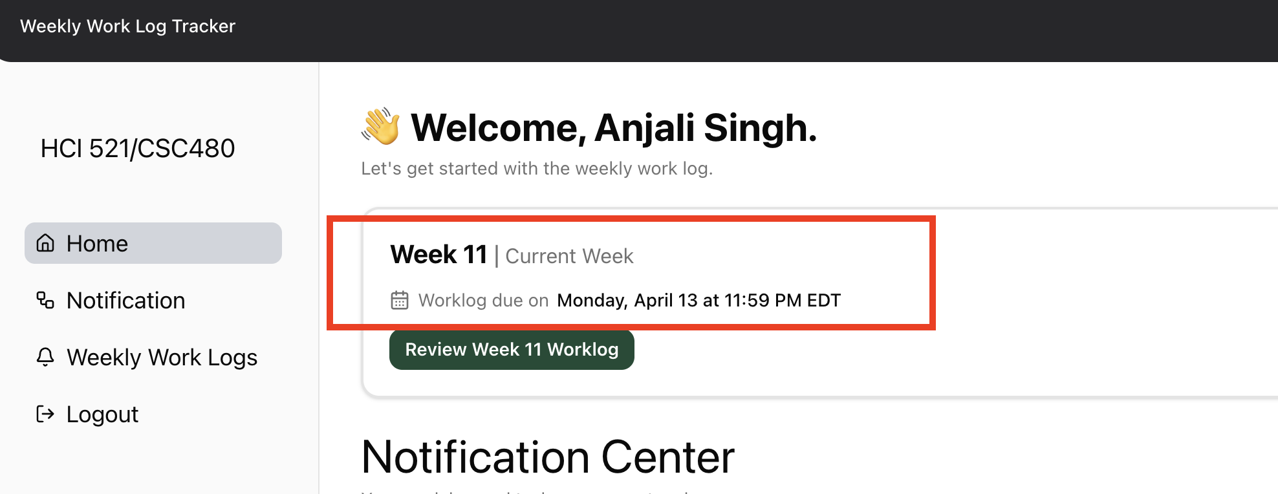

Homepage

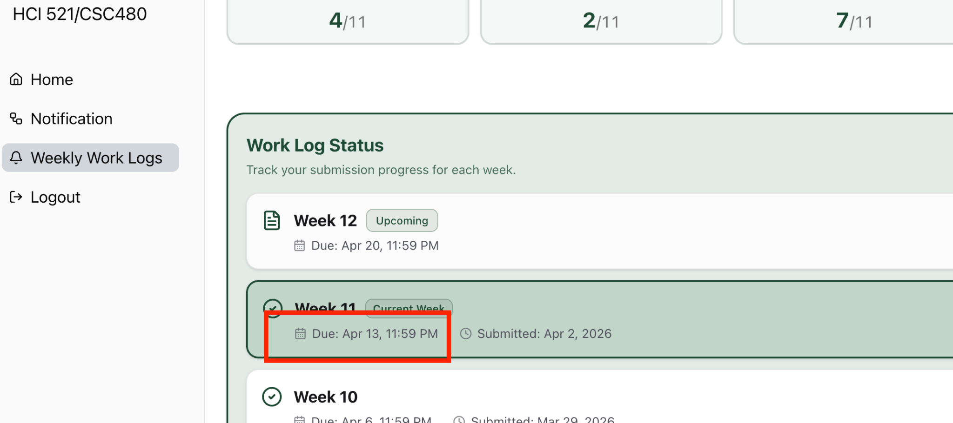
Weekly Work Log Page

FR 6 - RETEST
STP Test Case # ST-5
Requirement tested: FR-6
Description: The system shall handle errors occurring during home page data retrieval.
Build: v0.3.0_20260405
Determination: SUCCESSFUL

Setup:
- Open Chrome browser on Windows OS
- Navigate to front-facing AWS server (https://lakertracks.duckdns.org/)
- Execute test

Execution:

- Log in as a student.
- Right click → Inspect.
- Go to the Network tab.
- Refresh the page once so API calls appear.
- Find the API request (fetch/XHR).
- Right-click on that API request.
- Click Block request URL.
- Refresh the page again and check.

Expected Result:
The system shall display an appropriate error message when an API call fails during home page data retrieval. The message shall clearly indicate that the data could not be retrieved.

Screenshot:
The homepage shows an error message when the API is blocked and does not populate the content.
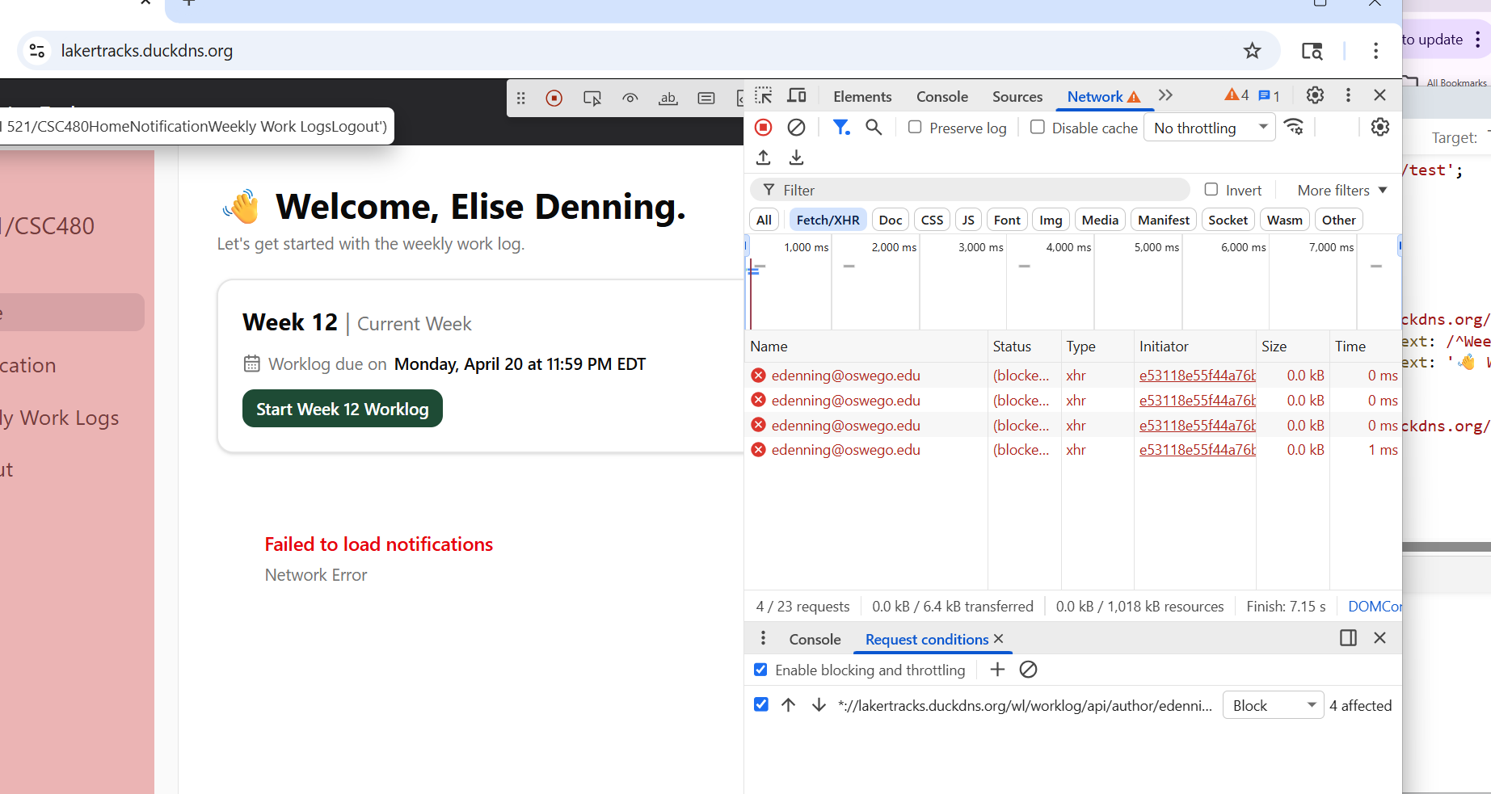

FR 8.1, 8.2 - RETEST
STP Test Case # ST-4
Requirement tested: FR-8.1
Description: The system shall log home page load events.
Build: v0.3.0_20260405
Determination: SUCCESSFUL

Setup:
- Open Chrome browser on Windows OS
- Navigate to front-facing AWS server (https://lakertracks.duckdns.org/)
- Execute test

Execution:
- Log onto the AWS server
- refresh/ loaded the server
- Look for a loading message on the home page

Expected Results: A text "Loading" to appear for loading events

Actual Results: A loading message for the loading notification
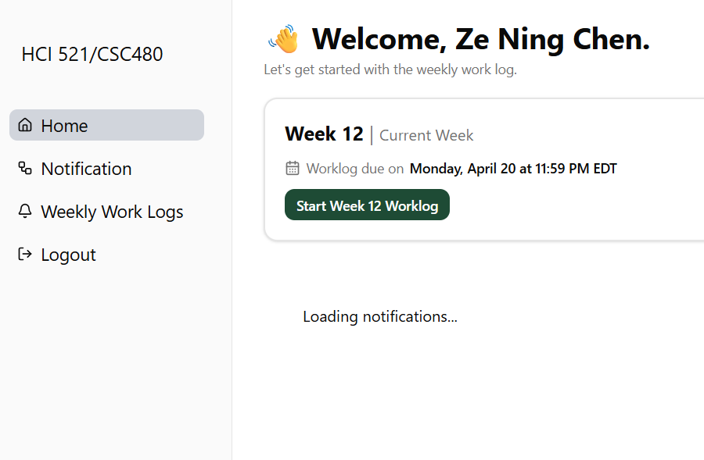
STP Test Case # ST-4
Requirement tested: FR-8.2
Description: The system shall log data retrieval failures related to home page loading.
Build: v0.3.0_20260405
Determination: SUCCESSFUL

Setup:
- Open Chrome browser on Windows OS
- Navigate to front-facing AWS server (https://lakertracks.duckdns.org/)
- Execute test

Execution:
- Log onto the AWS server
- Turned off my wifi
- Tried clicking around to find an error message

Expected Results:
1. If homepage data fails, log should be generated.
2. The log has information such as event type triggered, failure reason, timestamp of the event, event status
3. An no internet connection

Actual Results:
No internet connection error message
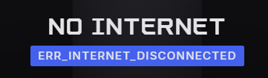

FR 9.1 - RETEST
Requirement tested: FR-9.1
Description: The system shall record the timestamp when a worklog is submitted.
Build: v0.2.0_20260325
Determination: SUCCESSFUL

Setup:

- Open Chrome browser on Windows OS
- Navigate to front-facing AWS server (https://lakertracks.duckdns.org/)
- Execute test

Execution:

- Log in as a student.
- Navigate to the Worklogs page.
- Fill in required worklog fields.
- Click Submit Worklog.
- Open the submitted worklog (or submission confirmation/details page).
- Observe the submission timestamp shown next to worklog submission on the Notification page.

Expected Result:
The user should be able to submit a worklog and see that the system records a submission timestamp, and the timestamp shown should match the date/time the worklog was submitted. Timestamp should be seen on the Notification page, next to each submitted worklog.

Actual Result:
The correct date is displayed next to submitted.

FR 12.1 - RETEST
STP Test Case # ST-5
Requirement tested: FR-12.1
Description: The system shall allow filtering of submissions by student name.
Build: v0.3.0_20260405
Determination: SUCCESSFUL

Setup:
- Open Chrome browser on Windows OS
- Navigate to front-facing AWS server (https://lakertracks.duckdns.org/)
- Execute test

Execution:
- Log in with valid Instructor id
- Go to Home page
- Select search bar
- Type in student’s name to filter it
- View students submissions by name

Expected Result:
Instructor should be able to search for a student by their name.

Screenshot:

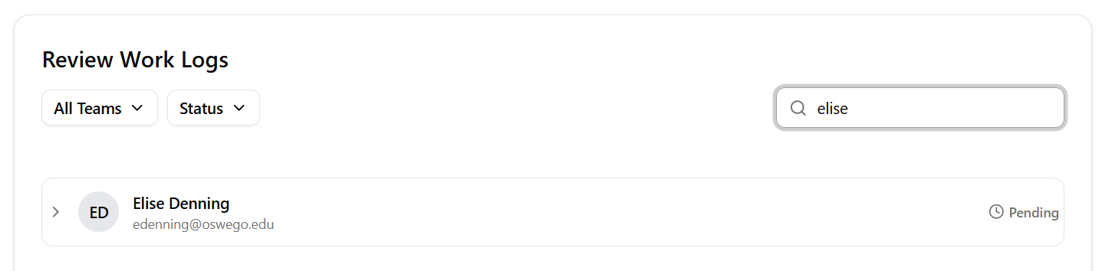

ST-5 BUGS_DEFECTS

Bug/Defect # ST-5_Defect - 1

Severity: Low

STP Test Case: # ST-5
Requirement Tested - FR 12.1
Build/Release #v0.3.0_20260405

Steps during test:
- Open Chrome browser on Windows OS
- Log in to Instructor Homepage on AWS website
- Select the search bar
- Start typing a student name to look up

Description:
The page does not scroll once you start utilizing the search bar. The more letters you enter, the lower on the page the results appear and page scrolling is not available.

Potential Cause (if known):
This problem occurs when using Playwright. Just going to the normal AWS server, the problem does not occur. This may be a problem with Playwright.
Screenshots of error:

Bug/Defect # ST-5_Defect - 2

Severity: Medium

STP Test Case: # ST-5
Requirement Tested - FR 9.3
Build/Release #v0.3.0_20260405

Steps during test:
- Open Chrome browser on Windows OS
- Log in to Student Homepage on AWS website
- Fill in and submit an incomplete worklog
- View the submission date and deadline

Description:
The system does not properly show the correct amount of days late a submission is

Potential Cause (if known):
May be because since it wasnt submitted technically 48 hrs late its not considered 2 days and is instead rounding down to one day
Screenshots of error:


